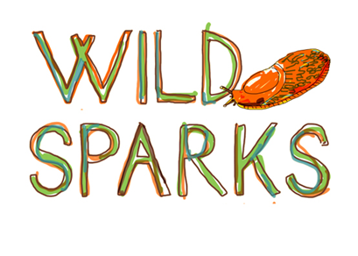

Food and Nutrition Policy

 | Date | Name & Position
Created | Jan 2017 | Jo Andrews, Manager/director
Reviewed / updated | April 2018 | Jo Andrews, Manager/director
Reviewed / updated | June 2019 | Alice Warren, Manager/director
Reviewed / updated | May 2020 | Alice Warren, Manager/director
Reviewed / updated
Reviewed / updated

This policy should be reviewed annually or light of any incident which requires a review.

At Wee Wild Sparks we take food seriously! Food preparation, eating together, foraging and cooking are all essential to children’s wellbeing and integral to the curriculum. We provide both lunch and a snack every day and is free of charge to families accessing their 1140 funded hours. Families attending outwith their free funded hours can pay a small fee to receive the lunch, snack is provided free for all.

Snacks
A snack of oatcakes and spreadable toppings is provided in the morning, with a warm drink of fruit/mint tea. Staff prepare and serve the snack, observing hygiene procedures for adults and children.

Lunch
Lunch is served at 11.45am and comprises a cold buffet style lunch. Each meal includes a variety of different foods which reflect the government guidance on nutrition. We aim to offer a choice from each food group to meet a wide range of dietary preferences.
Children are encouraged to help prepare and serve food, embedding practical maths through counting of receptacles, sorting and sharing different foods and developing fine motor skills through spreading, use of tongs and opening packets.
Adults and children eat together and the communal experience lends itself to discussion of different foods and their value to our bodies. Children are encouraged to start with savoury food and save sweet things until last.
Food is stored and transported in accordance with EHO requirements, utensils and receptacles are cleaned off site in an EHO registered premises.
Children are actively involved in shopping each week, using our i-pad and laminated visual guides to select foods they like or new things they want to try, creating further learning opportunities in numeracy (budgeting, planning quantities) and IT skills.
Our lunch shopping has lots of flexibility and therefore we can accommodate most dietary preferences. However, parents may choose to send something extra to top up their child’s lunch and should let us know if this is the case. We will monitor food brought from home to ensure it is both healthy and practical to eat in the forest environment and may suggest changes if necessary. In winter parents may send a hot beverage in a flask (see below) which we encourage.
Drinks
We have no running water on site so ask that Parents send a flask of water each day to reduce the weight-load in staff rucksacks. Spare water is available for top ups or in case of spillages or forgotten flasks. In winter we suggest parents send a warm drink of herbal tea or warm milk in a thermos.

Campfire cookery
Is an integral part of the curriculum, with cookery activities linked to the seasons, stories and the children’s preferences and interests. Important dates in the calendar are marked through the preparation of food; pancakes for leaving days, mince pies at Christmas.
An emphasis is placed on healthy and low sugar foods, some favourites are;
- Toast
- Vegetable Soup
- Roasted apples
- Popcorn
- Oat cakes
- Pancakes
- Cherry tomatoes
Children are actively encouraged to make suggestions for (healthy) cooking activities.

Food Allergies and intolerances
Parents inform staff of any allergies at registration. A list is kept of any dietary needs and this is consulted when planning cooking to make sure activities are inclusive and safe for all.
If a child has an allergy then we will discuss this with the family to put appropriate precautions in place, taking a measured approach on a case by case basis. If the risk is high, for example risk of anaphylactic reaction to a particular food, then that food will be entirely excluded from the premises, including in any foods brought from home by other children.

