What is Wee Wild Sparks?
​Wee Wild Sparks is a fully registered outdoor nursery, providing quality day care and learning for children aged 3-7 years. We are a small, family-friendly service run by experienced and qualified staff with a passion for outdoor learning and early years education.
The nursery is based in 7 acres of mixed woodland, on a private estate, on ​the edge of Coupar Angus and Burrelton, PH13.
At Wee Wild Sparks young children are free to play and learn at their own pace, in their own way, inspired by the changing seasons and stimulating woodland surroundings. ​We opened our invisible doors in January 2017 and have since been supporting children to grow, play and learn through a nature-based pedagogy, fully compatible with Curriculum for Excellence.
Opening Times & Days
Wee Wild Sparks is open on a Monday, Tuesday and Thursday and children can attend for anything from one up to three days per week.
The nursery day starts with drop off at 8.45am and pick up at 3.30pm. Currently only full days are available.
The nursery is open 39 weeks of the year aligning with the main Perth & Kinross holidays.
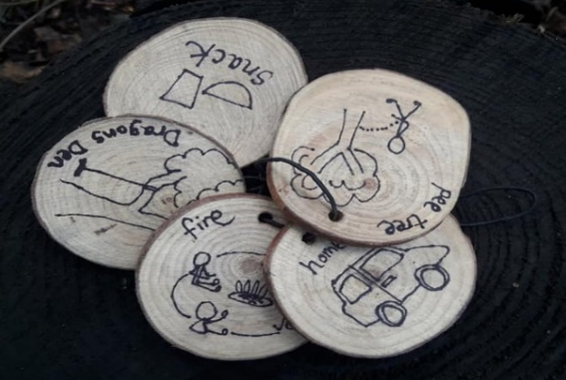

Child Age & Group Size
The nursery welcomes children aged 3 up to 7 years, to support home-schooling or flexi-schooling arrangements.
The maximum number of children per day is 18 and at least three nursery staff are always with the group.

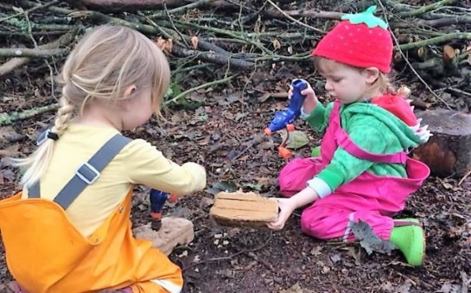

Fees (2019/20) & Local Authority Funded Places
£33.00 per day
(Perth & Kinross Council term time only)

Fees are invoiced over 10 months (August – May). An additional end of year settling up invoice may also be issued.
We offer funded places to Perth & Kinross families in partnership with Perth & Kinross Council. However cross-border funding may also be possible in certain circumstances.
You may be eligible for other help with childcare costs through government schemes, we can advise you on this.

A Day at Wee Wild Sparks
Each morning the children journey around ½ mile from the meeting place, alongside fields and into the woods. There they will find our favourite play places, including ‘Dragon’s Den’, and numerous spots for digging and climbing. Throughout the day there are shared times when we eat, tell stories and warm up around the campfire.
Children are free to run around or take it easy to match their energy levels, with supportive staff on hand to make sure they are keeping warm and dry. Our children soon build stamina and learn to understand and respond to their bodies' needs, especially those who attend for 2 or more days.

Preparing for Outdoor Play
Clothing
Wee Wild Sparks is open during all seasons. Therefore, we emphasise the importance of sending your child fully prepared, whatever the weather!
Children who are dressed to be warm and waterproof will enjoy themselves even when it is cold and wet. A kit list will be provided and if you follow our advice and provide enough spare clothing, your child will stay warm and dry and be able to enjoy the Wee Wild Sparks experience.
There is a large cabin heated by a stove, where children can go to warm up on a cold day and big tarps that are rigged up over our favourite spots for sheltered play in wet weather.

Eating & Handwashing
Children are asked to bring a packed lunch and we provide a healthy snack and a warm drink every day.
We carry in warm water and soap to ensure children's hands are germ free before eating and after using the toilet.

Going to the Loo!
There is a composting toilet onsite, with a child size seat and handwashing facilities. We have designated pee trees in different parts of the woods, for boys (and girls if they like) and can provide a potty if that is your child’s preference.
Regardless of where they ‘go’ we make sure that all children are clean and comfortable after every loo visit.
We are also equipped and happy to take children in nappies, we simply request that you provide the nappies and wipes and are happy to use cloth nappies if that is your preference.

How will I know what my child is learning?
We use an innovative online system, Evidence Me for assessment, recording and reporting each child's learning and development.
Parents receive regular updates with photos and observations, clearly outlining how their child is meeting different experiences and outcomes of Curriculum for Excellence.
Additionally, the things your child says and does will show you! You may well notice them growing in confidence, independence, adventurousness, and showing a positive approach to solving problems.
Staff will give you a verbal update at pick-up time, when your child will often greet you with a handful of sticks, leaves, pebbles, providing starting points for discussion.

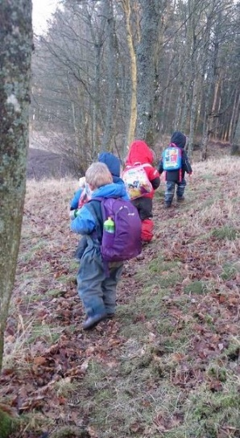

Pre-enrolment Visit
We strongly recommend that all interested parents and children visit the nursery prior to enrolling so they can meet the staff and experience Wee Wild Sparks.
After completing our online enquiry form, we will arrange for you to visit the nursery for a couple of hours while it is open on a Monday, Tuesday or Thursday. We also run occasional stay and play sessions, please let us know if these would be of interest.
We also recommend a series of 2-3 half day transition visits, which can commence prior to your child turning 3.
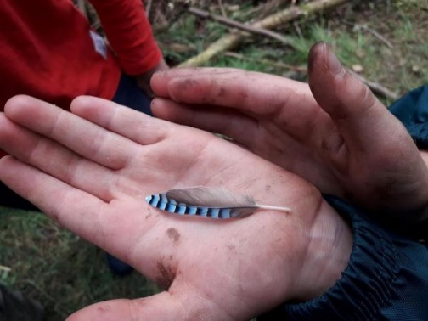

For more information please visit our website www.wildsparks.co.uk and specifically the Outdoor Nursery section. Alternatively, if you have any questions not answered in the above or online then please feel free to contact us at office@wildsparks.co.uk.

